**VISVESVARAYA TECHNOLOGICAL UNIVERSITY BELGAUM - 590014**



**A DBMS Mini-Project Report**

**On**

***“Employee Database Management System”***

*A Mini-project report submitted in partial fulfillment of the requirements for the award of the degree of* ***Bachelor of Engineering in Computer Science and Engineering***

*of Visvesvaraya Technological University, Belgaum.*

Submitted by:

**ANAND MOHAN SINGH (1DT17CS010)**

**AND**

**AMAN KULSHRESTHA (1DT17CS009)**

Under the Guidance of:

**Dr. Sandhya N (Assoc. Prof. Dept of CSE)**

**and**

**Mr. Manjunath D R (Asst. Prof. Dept of CSE)**





**Department of Computer Science and Engineering**

**DAYANANDA SAGAR ACADEMY OF TECHNOLOGY AND MANAGEMENT**

Kanakapura Road, Udayapura, Bangalore

2019-2020

(Accredited by NBA, New Delhi for 3 years validity: 26-07-2018 to 30-06-2021)

**DAYANANDA SAGAR ACADEMY OF TECHNOLOGY AND MANAGEMENT,**

Kanakapura Road, Udayapura, Bangalore

**DEPARTMENT OF COMPUTER SCIENCE & ENGINEERING**



**CERTIFICATE**

This is to certify that the Mini-Project on Database Management System (DBMS) entitled **“EMPLOYEE DATABASE MANAGEMENT SYSTEM”** has been successfully carried out by **ANAND MOHAN SINGH (1DT17CS010) and AMAN KULSHRESTHA (1DT17CS009)** a bonafide students of **Dayananda sagar academy of technology and management** in partial fulfillment of the requirements for the award of degree in **Bachelor of Engineering in Computer Science and Engineering** of **Visvesvaraya Technological University, Belgaum** during academic year 2019-20. It is certified that all corrections/suggestions indicated forInternal Assessment have been incorporated in the report deposited in the departmental library. The mini project report has been approved as it satisfies the academic requirements in respect of project work for the said degree.

**GUIDES:**

**Dr. Sandhya N (Assoc. Prof. Dept of CSE) Dr. C. NANDINI**

**and (Vice Principal & HOD, Dept. of CSE)**

**Mr. Manjunath D R (Asst. Prof. Dept of CSE)**

**Examiners:** **Signature with Date**

**1:**

**2:**

Table of Contents

**2** **Table of Figures** 6

**3** **ACKNOWLEDGEMENT** 7

**4** **ABSTRACT** 8

**5** **INTRODUCTION** 9

5.1 Background 9

5.2 Problem Definition 9

5.3 Motivation 9

5.3.1 Manual System: 9

5.3.2 Technical System: 9

With the invention of latest technology, we should update our systems which are very fast, accurate, user-friendly and reliable. 9

5.4 Objective 10

5.5 Scope of the project 10

**6** **REQUIREMENTS** 11

6.1 Hardware Requirements 11

6.2 11

6.3 Software Requirements 11

**7** **DESIGN** 12

7.1 Database Design 12

7.2 Database Schema 12

7.2.1 Database: companydb 12

7.2.2 Table: department 13

7.2.3 Table: employee 13

7.2.4 Table: salary 14

7.2.5 Table: project 14

7.2.6 Table: performance 14

**8** **Relational Schema** 15

8.1 Database: companydb 15

**9** **Database Normalization** 16

9.1 First Normal Form 16

9.2 Second Normal Form 16

9.3 Third Normal Form 16

9.4 User Interface 16

10 LOGIN PAGE 17

**11** **SIGNUP PAGE** 17

**12** **DEPARTMENT** 18

12.1 NEW ENTRY 18

12.2 VIEW 18

12.3 UPDATE 19

**13** **EMPLOYEE** 19

13.1 ENTRY 19

13.2 VIEW 20

13.3 UPDATE 20

**14** **SALARY** 21

14.1 ENTRY 21

14.2 VIEW 21

14.3 UPDATE 22

**15** **PROJECT** 22

15.1 ENTRY 22

15.2 VIEW 23

15.3 UPDATE 23

**16** **PERFORMANCE** 24

16.1 ENTRY 24

16.2 VIEW 24

16.3 UPDATE 25

**17** **CALC** 25

**18** **IMPLEMENTATION** 26

18.1 User Registration Module 26

18.2 User Login Module 26

18.3 HomePage 27

18.4 Entry/Update in Department 27

18.5 Entry/Update in Employee 28

18.6 Entry/Update in Salary 28

18.7 Entry/Update in Project 29

18.8 Entry/Update in Performance 29

**19** **SOURCE CODE** 30

19.1 Sample Source Code for Login 30

**20** **CONCLUSION AND FUTURE WORK** 34

20.1 Advantages 34

20.2 Future Enhancements 34

**21** **BIBLIOGRAPHY** 35

21.1 BOOK REFERENCES: 35

21.2 WEBSITE REFERENCES: 35

21.2.1 HTML Learning: 35

21.2.2 PHP Learning: 35

21.3 Contact Details: 35

# **Table of Figures**

Figure 1LOGIN PAGE 17

Figure 2SIGNUP PAGE 17

Figure 3DEPARTMENT ENTRY 18

Figure 4DEPARTMENT VIEW 18

Figure 5DEPARTMENT UPDATE 19

Figure 6EMPLOYEE UPDATE 19

Figure 7EMPLOYEE VIEW 20

Figure 8EMPLOYEE UPDATE 20

Figure 9SALARY ENTRY 21

Figure 10SALARY VIEW 21

Figure 11SALARY UPDATE 22

Figure 12PROJECT ENTRY 22

Figure 13SALARY VIEW 23

Figure 14SALARY UPDATE 23

Figure 15PERFORMANCE ENTRY 24

Figure 16PERFORMANCE VIEW 24

Figure 17PERFORMANCE UPDATE 25

Figure 18CALC VIEW 25

# **ACKNOWLEDGEMENT**

It gives us immense pleasure to present before you our project titled **“EMPLOYEE DATABASE MANAGEMENT SYSTEM USING HTML and PHP”.** The joy and satisfaction that accompany the successfulcompletion of any task would be incomplete without the mention of those who made it possible. We are glad to express our gratitude towards our prestigious institution **DAYANANDA SAGAR** **ACADEMY OF TECHNOLOGY AND MANAGEMENT** for providing us with utmost knowledge,encouragement and the maximum facilities in undertaking this project.

We wish to express a sincere thanks to our respected principal **Dr. B. R. Lakshmikantha** for all their support.

We express our deepest gratitude and special thanks to **Dr.C.Nandini, Vice Principal & H.O.D, Dept.**

**Of Computer Science Engineering**, for all her guidance and encouragement.

We sincerely acknowledge the guidance and constant encouragement of our mini- project guides, **Dr. Sandhya N (Assoc. Prof. Dept of CSE) and Mr. Manjunath D R (Asst. Prof. Dept of CSE)**

**ANAND MOHAN SINGH(1DT17CS010)**

**AND**

**AMAN KULSHRESTHA(1DT17CS009)**

# **ABSTRACT**

In this world of growing technologies everything has been computerized. With large number of work opportunities the human workforce has increased. Thus there is a need of a system which can handle the data of such a large number of employee in an organization. This project simplifies the task of maintain record because of its user friendly nature.

The “Employee Database Management System” has been developed to override the problems prevailing in the practicing manual system. This software is supported to eliminate and in some cased reduce the hardships faced but this existing system. Moreover this system is designed for the particular need of the company to carry out operation in a smooth and effective manner.

The user interface provides the options to add, update and also delete the required fields of the employee and also calculate the hike of that particular employee by considering his performance in different projects at the same time.

The application is reduced as much as possible to avoid errors while entering the data. It also provides error messages at required time. No formal knowledge is needed to use this system. Thus by this all it proves it is user-friendly.

# **INTRODUCTION**

## Background

Observing the speed of world going ahead now a days, one need to be motivated all along to reach the desired. So, it would be very difficult to manage those reponsibilty manually as an leader. So,

The Employee performance management system sophisticatedly is the key ,digitally as an innovative solution that helps in managing. Employee details, processing, and analysing the performance. The

Employee performance management system simplifies the manual details managing process into an smooth administration of the management to performance and bonus.

## Problem Definition

This project is aimed to reduce the manual work involved in filing the employee details which led to bring out the this system . This project is developed mainly to simplify the manual work and allows smooth administration of the operations on Employee management and performance management. The effective purpose of the project is to computerize the operation of a employee detaiols and to make the admin retrieve and insert the employee details simple, faster, and without any interruptions. It deals with the Employee datils,project details ,performance details,department details and equiped with secured login ,logout and signup system.

## Motivation

### Manual System:

The system is very time consuming and irresponsible. This system is more prone to manage employe details and analysing the performance.

### Technical System:

### With the invention of latest technology, we should update our systems which are very fast, accurate, user-friendly and reliable.

## Objective

Main goal of this project is to simplify the manual operation of the Employee performance management system with the following advantages:

* Faster System
* Accuracy
* Reliability
* Monitoring
* User Friendly
* Immediate access to filing complaint and view statistics
* Based on performance, automatically salary is decided.

## Scope of the project

The project provides a very simple application which simplifies the manual work done by the operation team of Administration of company managing large number of employees. This application saves the issues of salary decision. Allows Admin users to input the insert the employee and company details using interactive Graphical User Interface, And admin only has the rights to manipulate or cancel the filed complaint meaningfully. Our project allows users to view the change in salary if there is any change in the salary.

# **REQUIREMENTS**

The requirements can be broken down into 2 major categories namely hardware and software requirements. The former specifies the minimal hardware facilities expected in a system in which the project has to be run. The latter specifies the essential software needed to build and run the project.

## Hardware Requirements

The Hardware requirements are very minimal and the program can be run on most of the machines.

|  |  |  |
| --- | --- | --- |
| • | Processor | - Intel 486/Pentium processor or better |
| • | Processor Speed | - 500 MHz or above |
| • | Hard Disk | - 20GB(approx.) |
| • | RAM | - 64MB or above |
| • | Storage Space | - Approx. 2MB |

|  |  |  |
| --- | --- | --- |
|  | Software Requirements | |
| • | Technology Implemented | : Apache Server, MySQL Server |
| • | Language Used | : PHP |
| • | Database | : My SQL |
| • | User Interface Design | : HTML, CSS, Bootstrap |
| • | Web Browser | : Google Chrome |
| • | Software | : WAMPP Version: 3.1.9 |

# **DESIGN**

## Database Design

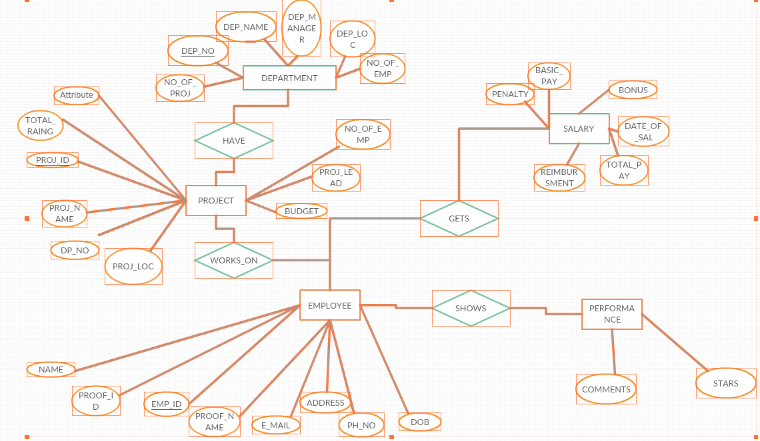

## Database Schema

### Database: companydb

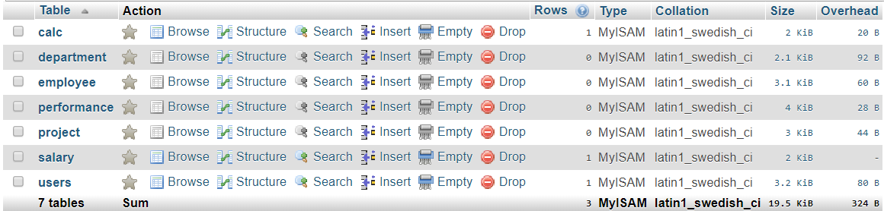

### Table: department

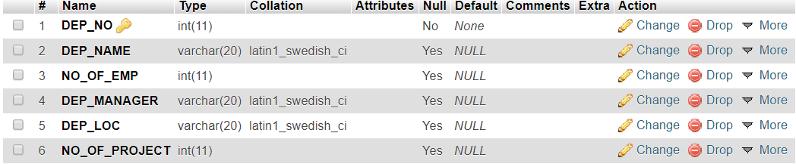

### Table: employee

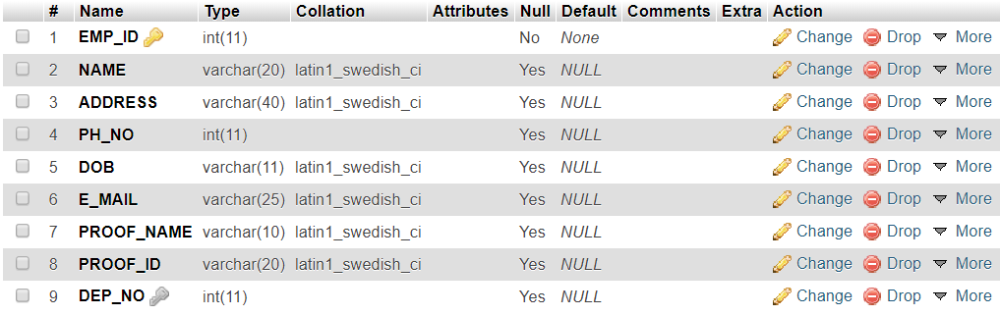

### Table: salary

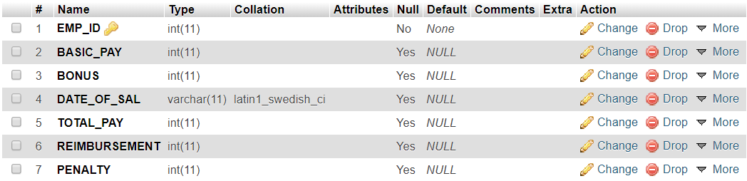

### Table: project

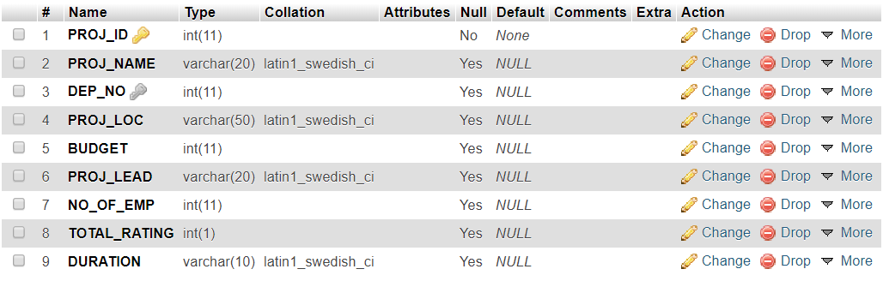

### Table: performance

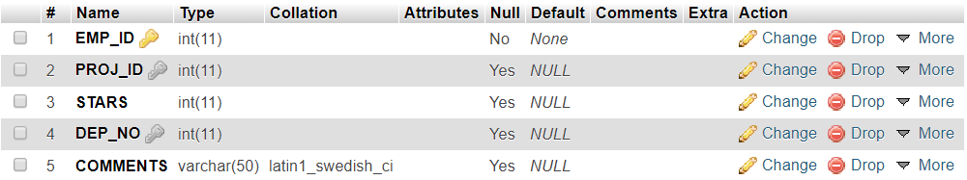

# **Relational Schema**

## Database: companydb

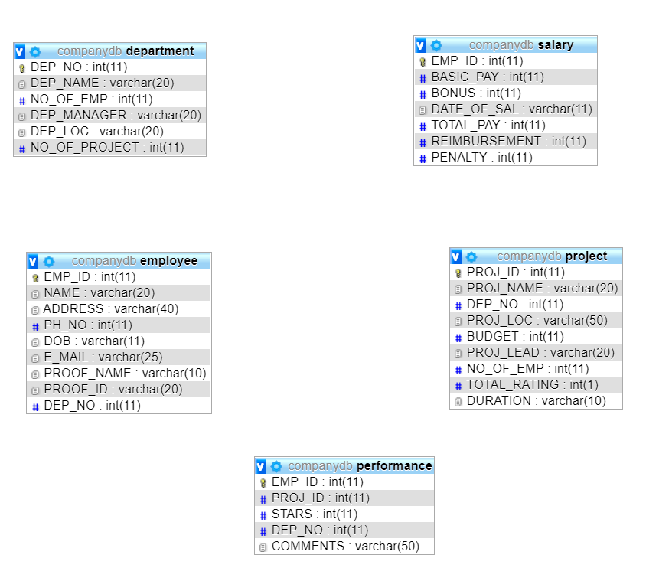

# **Database Normalization**

## First Normal Form

All the Relations are designed in such a way that it has no repeating groups. Hence all tables are in 1st Normal Form.

## Second Normal Form

A relation is said to be in second normal form if it is already in first normal form and it has no partial dependency. All the tables in the database are designed in such a way that there is no partial dependency. Hence all tables are in 2nd Normal Form.

## Third Normal Form

A relation is said to be in third normal form if it is already in 1st and 2nd Normal Form and has no transitive dependency. All the tables in the database are designed in such a way that there is no transitive dependency. Hence all tables are in 3rd Normal Norm.

## User Interface

The User Interface of the Complaint Management System (Post Complaint Freely) is divided into two parts:

1. User Module - For the users registered to post complaints
2. Admin Module – For the admin/owner(users) of the CMS

# LOGIN PAGE

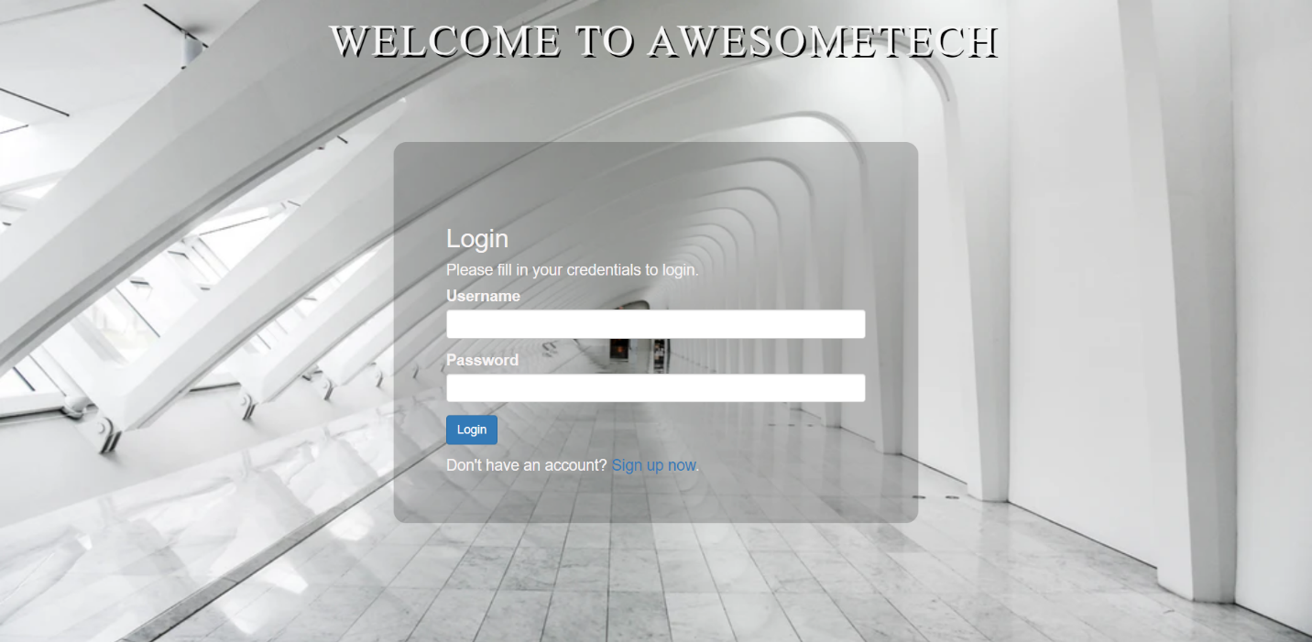

Figure LOGIN PAGE

# **SIGNUP PAGE**

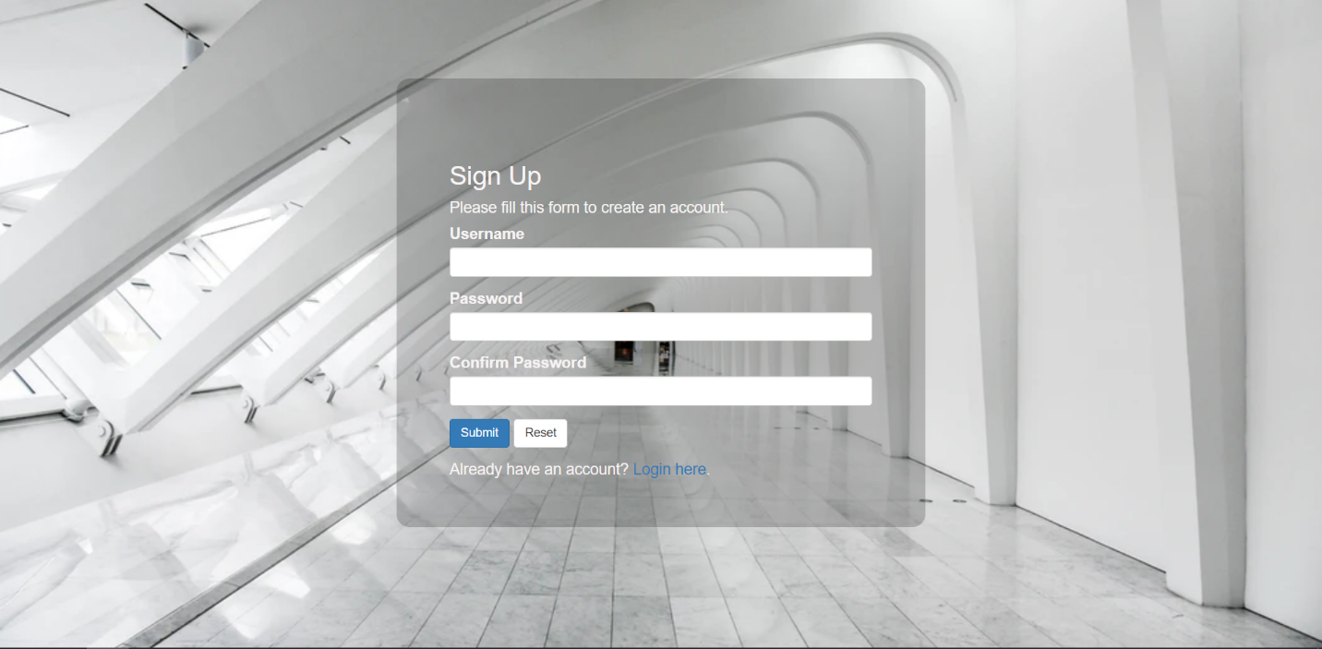

Figure SIGNUP PAGE

# **DEPARTMENT**

## NEW ENTRY

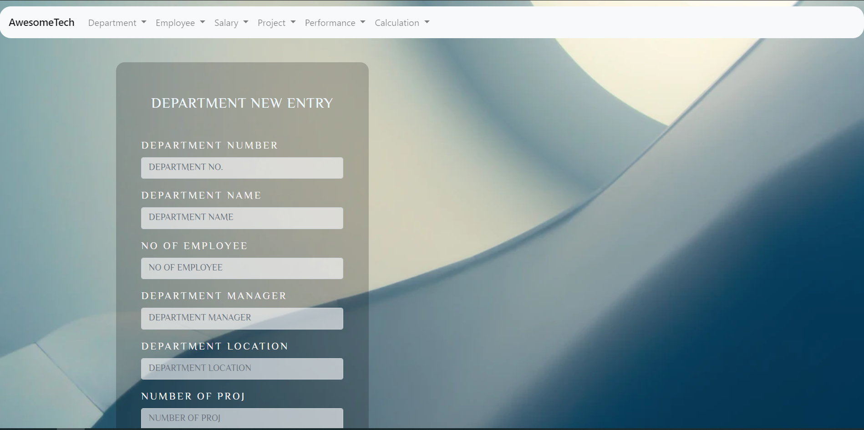

Figure DEPARTMENT ENTRY

## VIEW

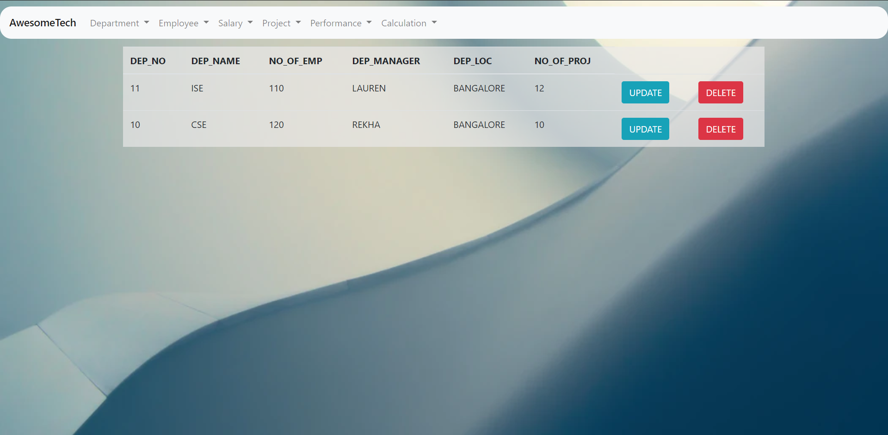

Figure DEPARTMENT VIEW

## UPDATE

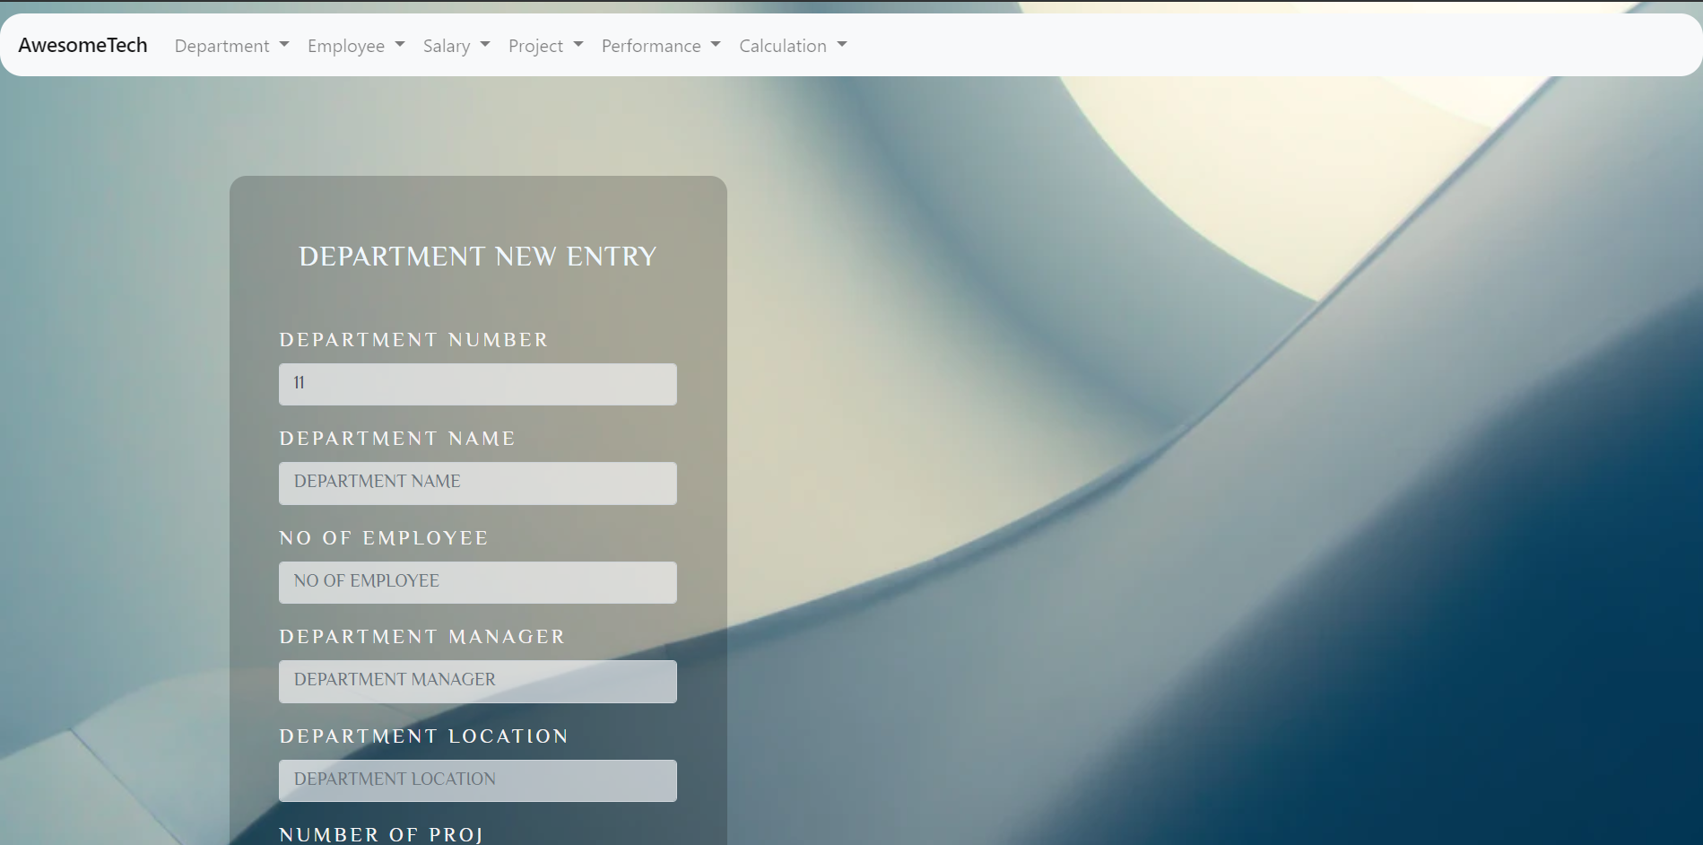

Figure DEPARTMENT UPDATE

# **EMPLOYEE**

## ENTRY

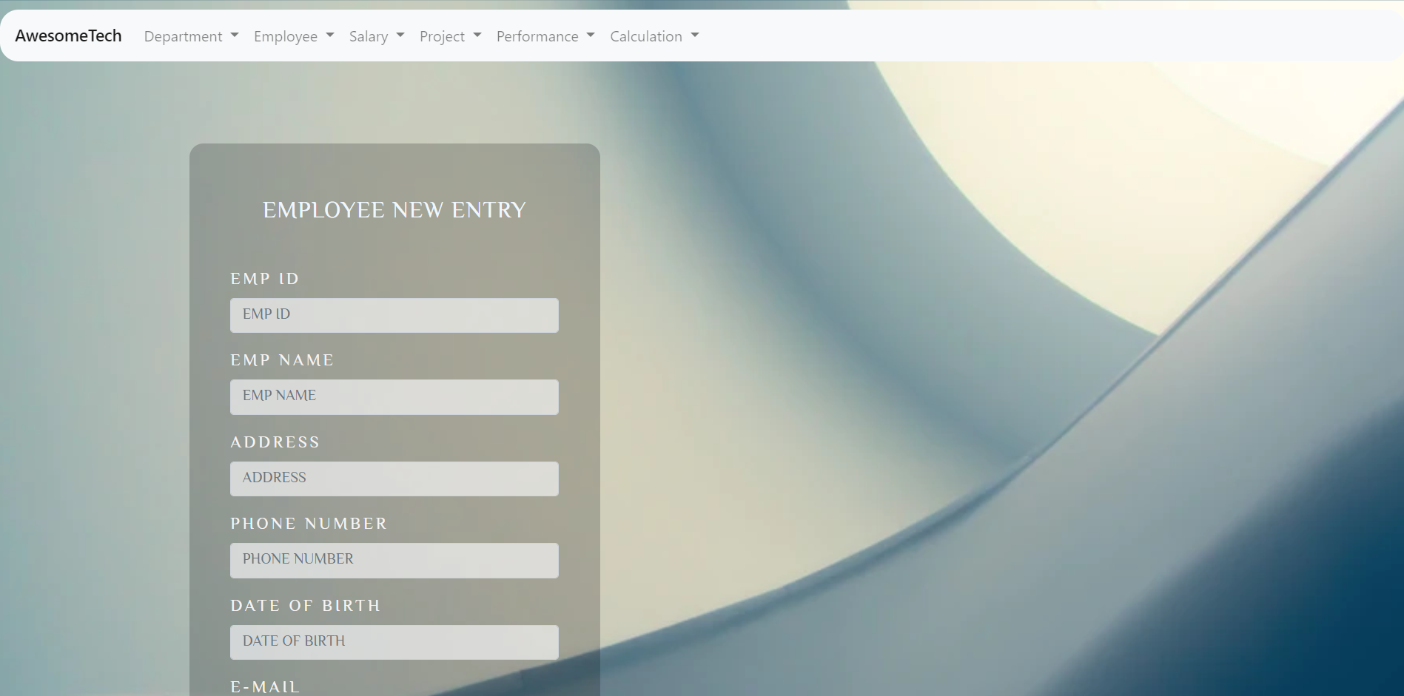

Figure EMPLOYEE UPDATE

## VIEW

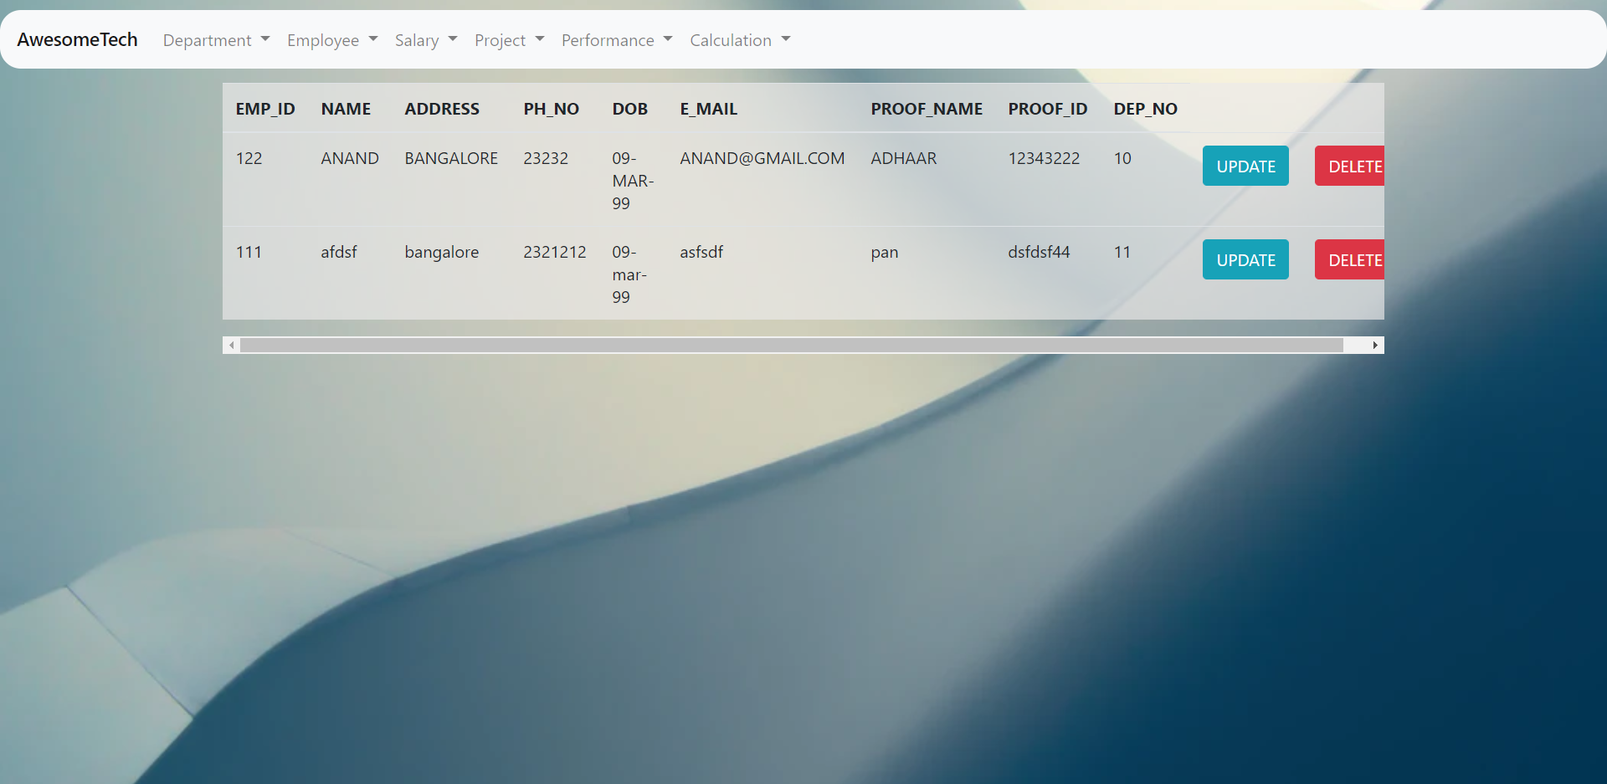

Figure EMPLOYEE VIEW

## UPDATE

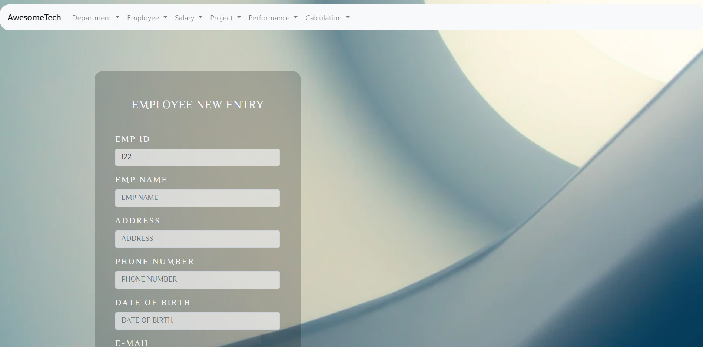

Figure EMPLOYEE UPDATE

# **SALARY**

## ENTRY

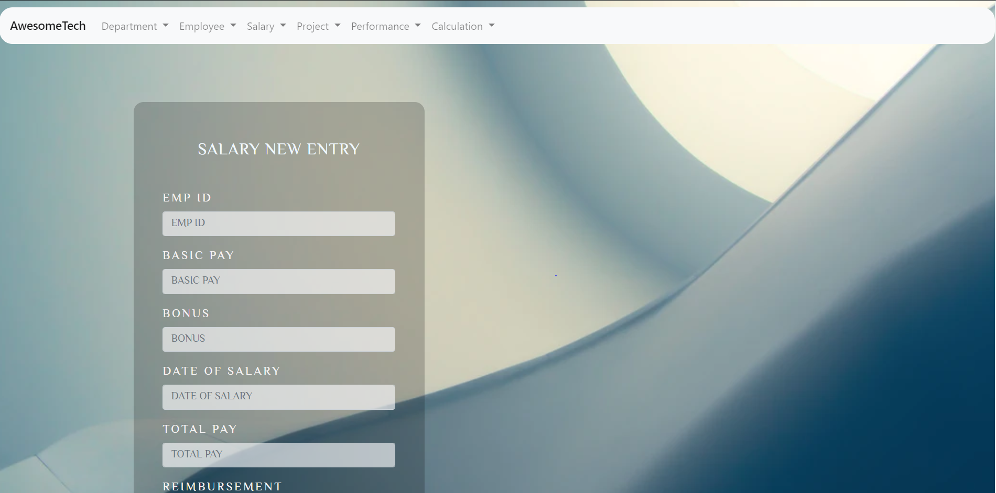

Figure SALARY ENTRY

## VIEW

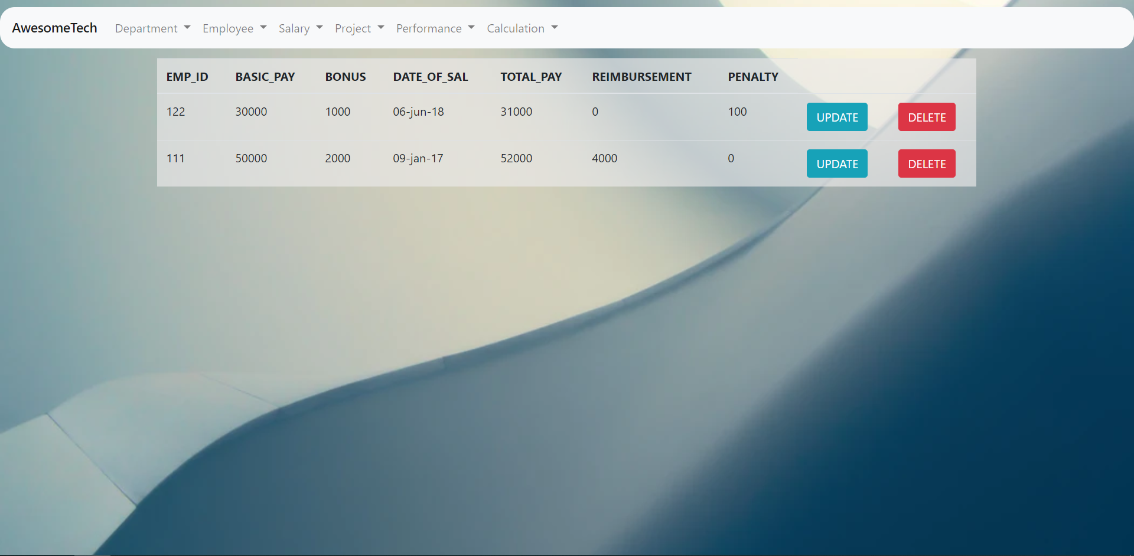

Figure SALARY VIEW

## UPDATE

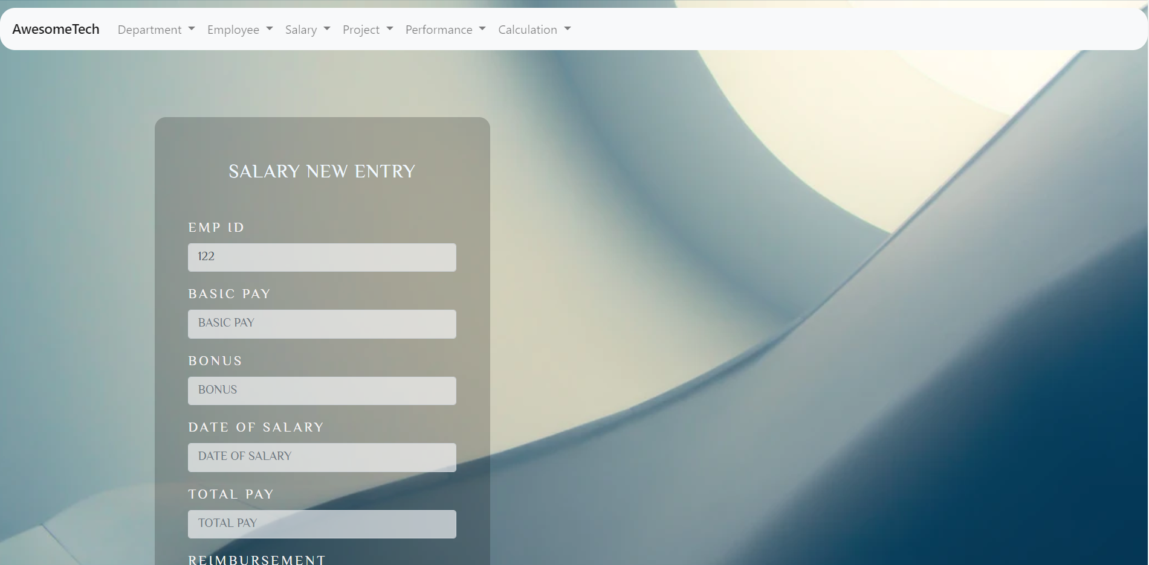

Figure SALARY UPDATE

# **PROJECT**

## ENTRY

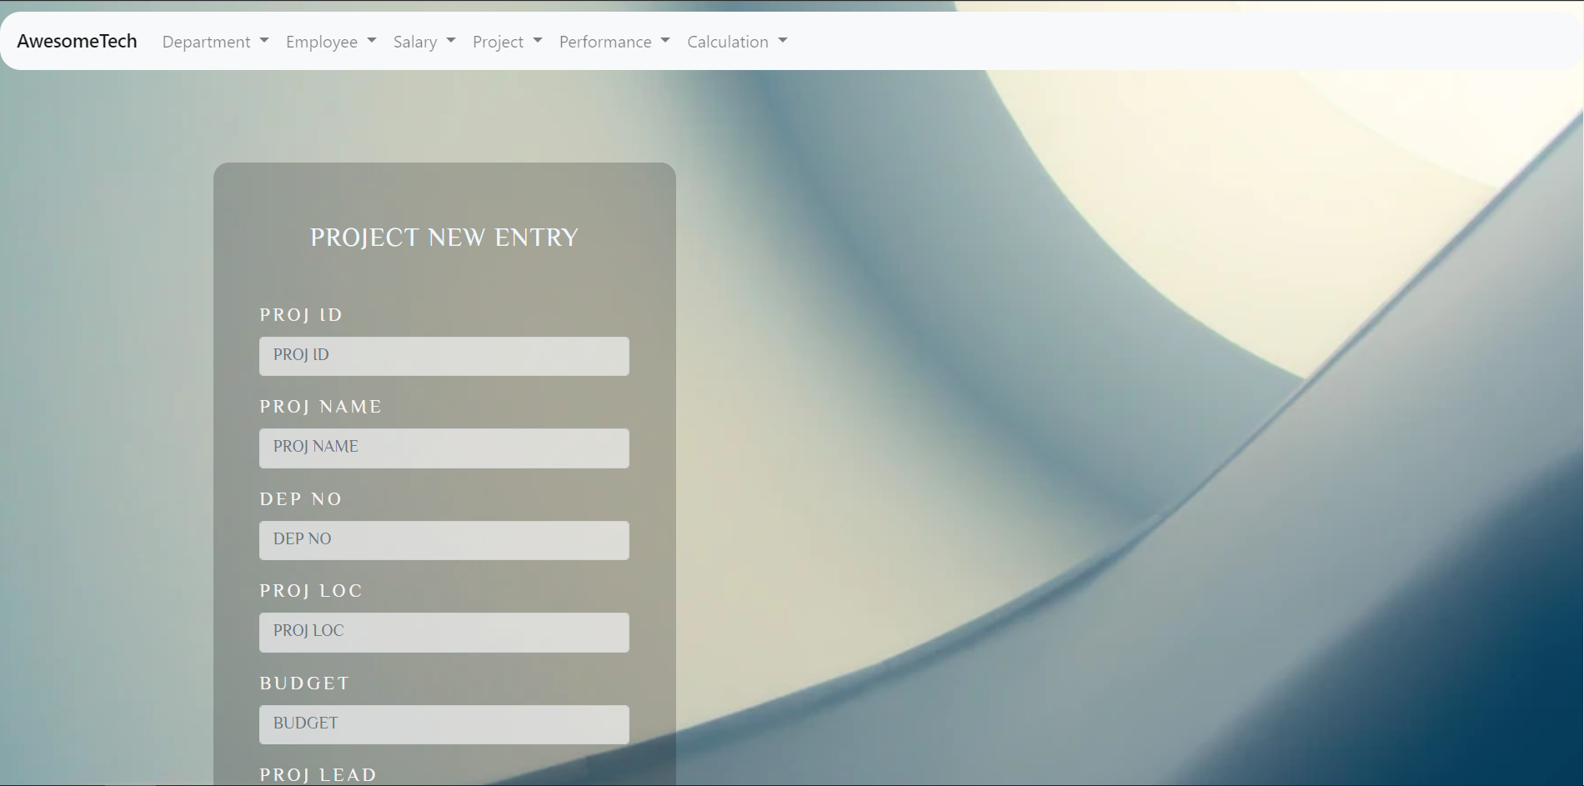

Figure PROJECT ENTRY

## VIEW

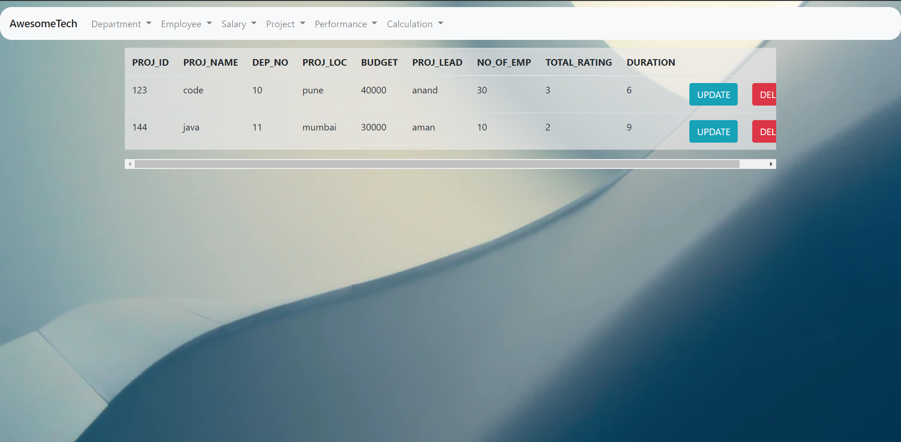

Figure SALARY VIEW

## UPDATE

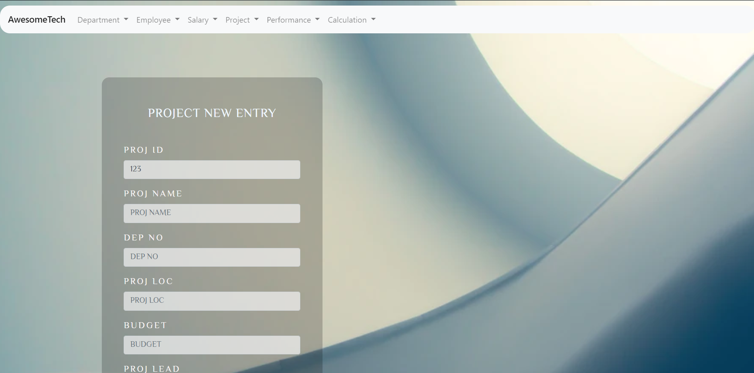

Figure SALARY UPDATE

# **PERFORMANCE**

## ENTRY

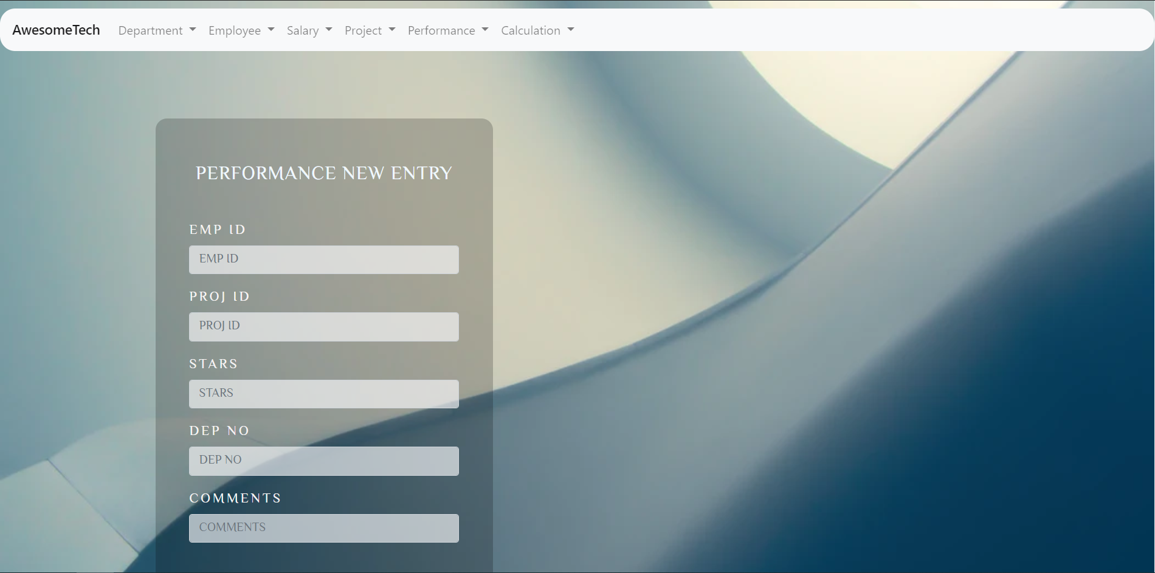

Figure PERFORMANCE ENTRY

## VIEW

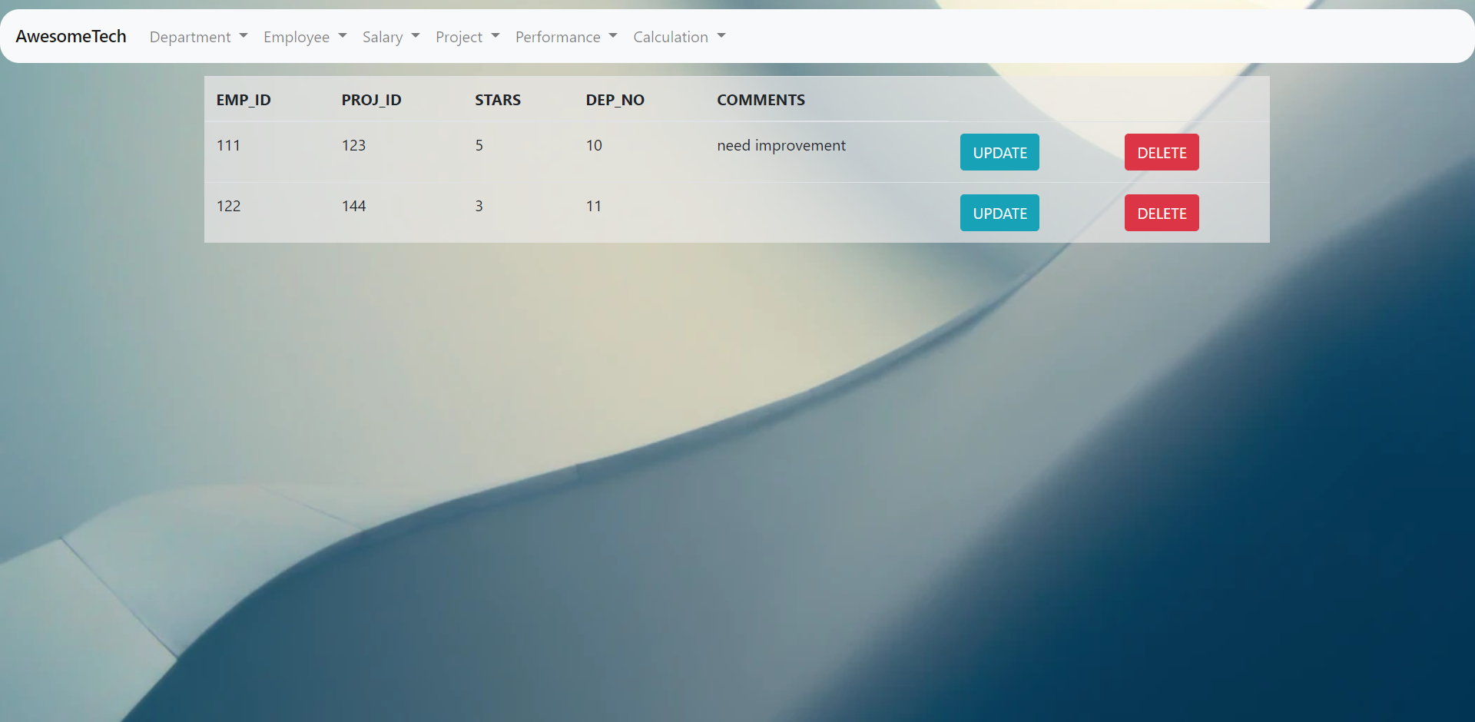

Figure PERFORMANCE VIEW

## UPDATE

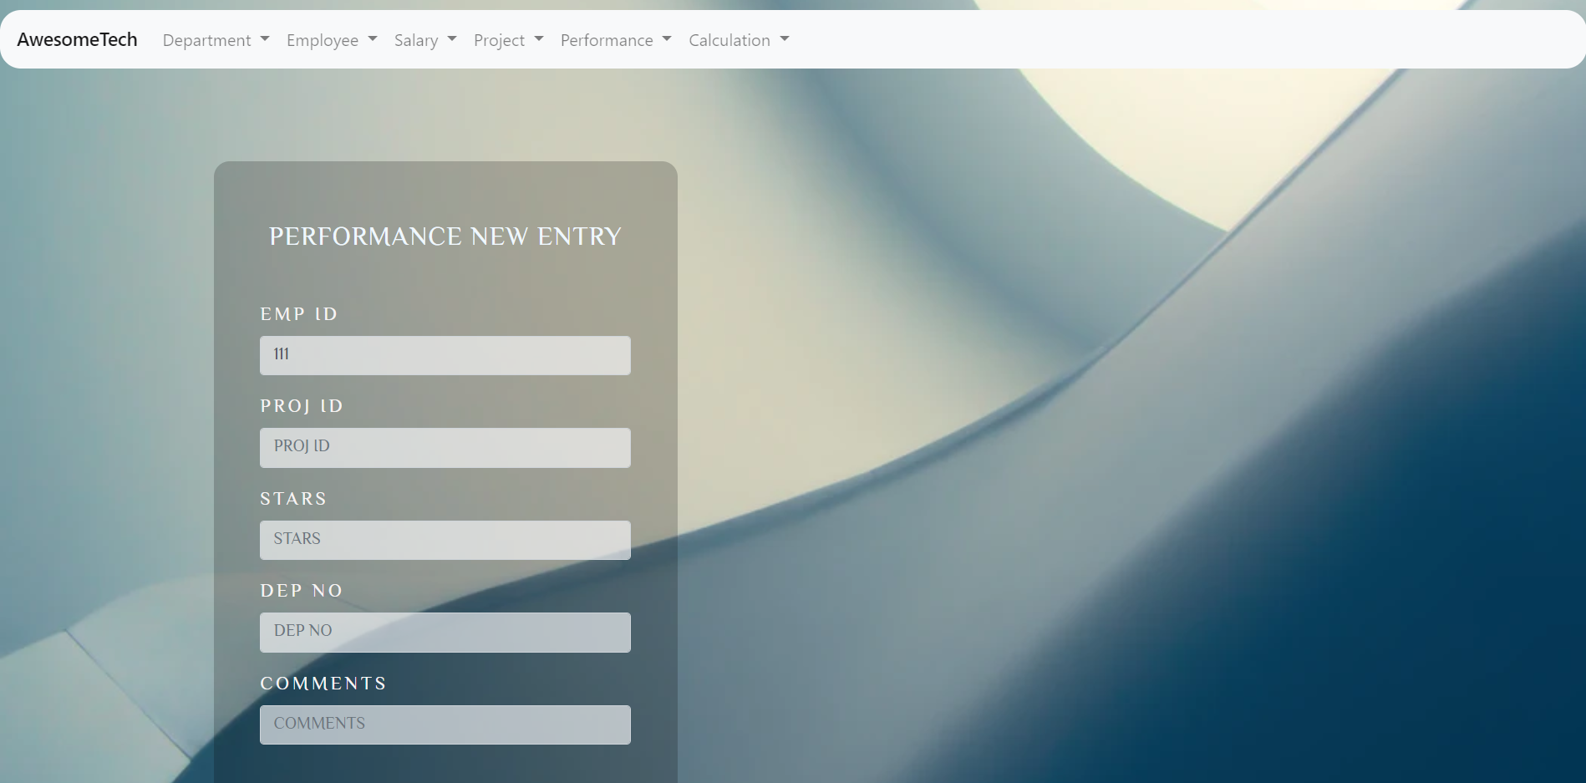

Figure PERFORMANCE UPDATE

# **CALC**

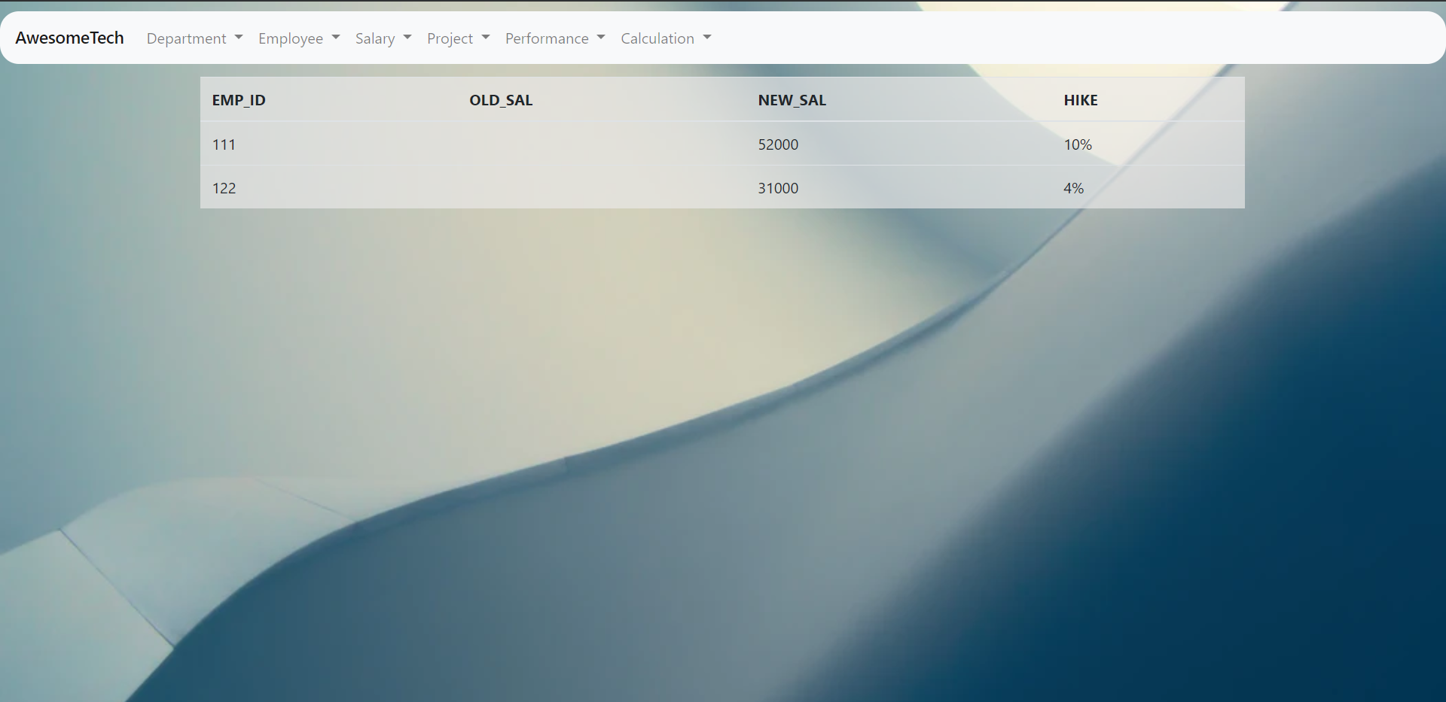

Figure CALC VIEW

# **IMPLEMENTATION**

## User Registration Module

|  |  |
| --- | --- |
| **Process Name** | **: User Registration** |
| Process Number | : 1.1 |
|  |  |
| Input | : UserId |
|  | : Password |
|  | : Confirm Password |
|  |  |
|  |  |
|  |  |
|  |  |
| Output | : Status Message |
|  |  |
| Error Condition | : Username Already Exists |
|  | : Passwords do not match |
|  | : All Fields are Required |
|  |  |

## User Login Module

|  |  |
| --- | --- |
| **Process Name** | **: User Login** |
| Process Number | : 1.2 |
|  |  |
|  | : Username |
| Input | : Password |
|  |  |
| Output | : Status Message |
|  |  |
| Error Condition | : Invalid Username or Password |
|  | : All Fields are Required |
|  |  |

## HomePage

|  |  |
| --- | --- |
| **Process Name** | **: Home Page** |
| Process Number | : 1.3 |
|  |  |
|  | :Nothing |
| Input |  |
|  |  |
| Output | : HomePage |
|  |  |
| Error Condition | :Nothing |
|  |  |
|  |  |

## Entry/Update in Department

|  |  |
| --- | --- |
| **Process Name** | **: Entry** |
| Process Number | : 1.4 |
|  |  |
|  | Dep_no  Dep_name  No_of_emp  Dep_manager  Dep_loc  No_of_project |
| Input |  |
|  |  |
| Output | : Entry successful |
|  |  |
| Error Condition | : Invalid Entry message |
|  |  |
|  |  |

## Entry/Update in Employee

|  |  |
| --- | --- |
| **Process Name** | **: Entry** |
| Process Number | : 1.5 |
|  |  |
|  | EMP_ID  NAME  ADDRESS  PH_NO  DOB  E_MAIL  PROOF_NAME  PROOF_ID  DEP_NO |
| Input |  |
|  |  |
| Output | : Entry successful |
|  |  |
| Error Condition | : Invalid Entry message |
|  |  |
|  |  |

## Entry/Update in Salary

|  |  |
| --- | --- |
| **Process Name** | **: Entry** |
| Process Number | : 1.6 |
|  |  |
|  | EMP_ID  BASIC_PAY  BONUS  DATE_OF_SAL  TOTAL_PAY  REIMBURSEMENT  PENALTY |
| Input |  |
|  |  |
| Output | : Entry successful |
|  |  |
| Error Condition | : Invalid Entry message |
|  |  |
|  |  |

## Entry/Update in Project

|  |  |
| --- | --- |
| **Process Name** | **: Entry** |
| Process Number | : 1.7 |
|  |  |
|  | PROJ_ID  PROJ_NAME  DEP_NO  PROJ_LOC  BUDGET  PROJECT_LEAD  NO_OF_EMP  TOTAL_RATING  DURATION |
| Input |  |
|  |  |
| Output | : Entry successful |
|  |  |
| Error Condition | : Invalid Entry message |
|  |  |
|  |  |

## Entry/Update in Performance

|  |  |
| --- | --- |
| **Process Name** | **: Entry** |
| Process Number | : 1.8 |
|  |  |
|  | EMP_ID  PROJ_ID  STARS  DEP_NO  COMMENTS |
| Input |  |
|  |  |
| Output | : Entry successful |
|  |  |
| Error Condition | : Invalid Entry message |
|  |  |
|  |  |

# **SOURCE CODE**

## Sample Source Code for Login

<?php

// Initialize the session

session_start();

// Check if the user is already logged in, if yes then redirect him to welcome page

if (isset($_SESSION["loggedin"]) && $_SESSION["loggedin"] === true) {

    header("location: ../Home/HomePage.html");

    exit;

}

// Include config file

require_once "config.php";

// Define variables and initialize with empty values

$username = $password = "";

$username_err = $password_err = "";

// Processing form data when form is submitted

if ($_SERVER["REQUEST_METHOD"] == "POST") {

    // Check if username is empty

    if (empty(trim($_POST["username"]))) {

        $username_err = "Please enter username.";

    } else {

        $username = trim($_POST["username"]);

    }

    // Check if password is empty

    if (empty(trim($_POST["password"]))) {

        $password_err = "Please enter your password.";

    } else {

        $password = trim($_POST["password"]);

    }

    // Validate credentials

    if (empty($username_err) && empty($password_err)) {

        // Prepare a select statement

        $sql = "SELECT id, username, password FROM users WHERE username = ?";

        if ($stmt = $mysqli->prepare($sql)) {

            // Bind variables to the prepared statement as parameters

            $stmt->bind_param("s", $param_username);

            // Set parameters

            $param_username = $username;

            // Attempt to execute the prepared statement

            if ($stmt->execute()) {

                // Store result

                $stmt->store_result();

                // Check if username exists, if yes then verify password

                if ($stmt->num_rows == 1) {

                    // Bind result variables

                    $stmt->bind_result($id, $username, $hashed_password);

                    if ($stmt->fetch()) {

                        if (password_verify($password, $hashed_password)) {

                            // Password is correct, so start a new session

                            session_start();

                            // Store data in session variables

                            $_SESSION["loggedin"] = true;

                            $_SESSION["id"] = $id;

                            $_SESSION["username"] = $username;

                            // Redirect user to welcome page

                            header("location:../Home/HomePage.html");

                        } else {

                            // Display an error message if password is not valid

                            $password_err = "The password you entered was not valid.";

                        }

                    }

                } else {

                    // Display an error message if username doesn't exist

                    $username_err = "No account found with that username.";

                }

            } else {

                echo "Oops! Something went wrong. Please try again later.";

            }

        }

        // Close statement

        $stmt->close();

    }

    // Close connection

    $mysqli->close();

}

?>

<!DOCTYPE html>

<html lang="en">

<head>

    <meta charset="UTF-8">

    <title>LOGIN</title>

    <link rel="stylesheet" href="https://maxcdn.bootstrapcdn.com/bootstrap/3.3.7/css/bootstrap.css">

    <style type="text/css">

        body {

            font: 14px sans-serif;

        }

        .wrapper {

            width: 350px;

            padding: 20px;

        }

    </style>

    <link rel="stylesheet" href="login1.css">

    <!-- Google Fonts -->

    <link href="https://fonts.googleapis.com/css?family=Philosopher&display=swap" rel="stylesheet">

    <link href="https://fonts.googleapis.com/css?family=El+Messiri&display=swap" rel="stylesheet">

</head>

<body>

        <h1>WELCOME TO AWESOMETECH<br></h1>

    <div class="wrapper">

        <h2>Login</h2>

        <p>Please fill in your credentials to login.</p>

        <form action="<?php echo htmlspecialchars($_SERVER["PHP_SELF"]); ?>" method="post">

            <div class="form-group <?php echo (!empty($username_err)) ? 'has-error' : ''; ?>">

                <label>Username</label>

                <input type="text" name="username" class="form-control" value="<?php echo $username; ?>">

                <span class="help-block"><?php echo $username_err; ?></span>

            </div>

            <div class="form-group <?php echo (!empty($password_err)) ? 'has-error' : ''; ?>">

                <label>Password</label>

                <input type="password" name="password" class="form-control">

                <span class="help-block"><?php echo $password_err; ?></span>

            </div>

            <div class="form-group">

                <input type="submit" class="btn btn-primary" value="Login">

            </div>

            <p>Don't have an account? <a href="register.php">Sign up now</a>.</p>

        </form>

    </div>

</body>

</html>

# **CONCLUSION AND FUTURE WORK**

The Employee Database Management System is a great improvement over the manual system which uses lots of manual work and paper. The computerization of the system speeds up the process. This system was thoroughly checked and tested with dummy data and found to be very reliable.

## Advantages

* The Complaint Management System is fast, efficient and reliable.
* Avoids data redundancy and inconsistency
* Web-based
* Eradicates conflicts between the employees and the customers
* Number of personnel required is considerably less
* Provides more security and integrity to data

## Future Enhancements

The Employee Database Management System can be enhanced by including more functionality like tracking the previous salary of employee from different year based on performance and making the graph of the performance of each and every department based on the review of the project that they have completed.

# **BIBLIOGRAPHY**

## BOOK REFERENCES:

1. Learn to Code HTML and CSS: Develop and Style Websites (Web Design Courses) 1st, Kindle Edition by Shay Howe
2. *PHP 6 and MySQL 5* - Larry Ullman

## WEBSITE REFERENCES:

### HTML Learning:

1. <https://www.codecademy.com/>
2. <https://dash.generalassemb.ly/>
3. <https://www.w3schools.com/>

### PHP Learning:

1. [http://www.tutorialspoint.com/php/](https://www.php.net/)
2. [https://killerphp.com](https://killerphp.com/)
3. <https://www.w3schools.com/>

## Contact Details:

Name : ANAND MOHAN SINGH, USN (1DT17CS010)

EMAIL : anandmohan.singh101@gmail.com

Name : AMAN KULSHRESTHA , USN (1DT16CS009)

EMAIL : akulshrestha1998@gmail.com